Chapter 4

**DICISION TREE CLASSIFIER**

**4.1 Offline Mode**

When farmer is offline, they will use offline mode. It is having low accuracy but works well if more image is taken. But it has manual segmentation system. Leaf must be on the rectangle area.

Rectangle area

Image

HSV Green Image

Input area

Output fertilizer

Check 70% > Green color

Predict

Decision Tree

Figure 3.7: Overall offline mode

**4.2 Decision Tree Classifier**

Making a CSV file with time and making the average of red, green and blue.

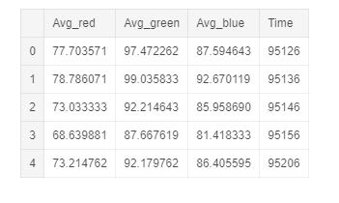

Figure 3.8:CSV file with AVG (Red, Green,Blue) and Time

Creating decision tree classifier.

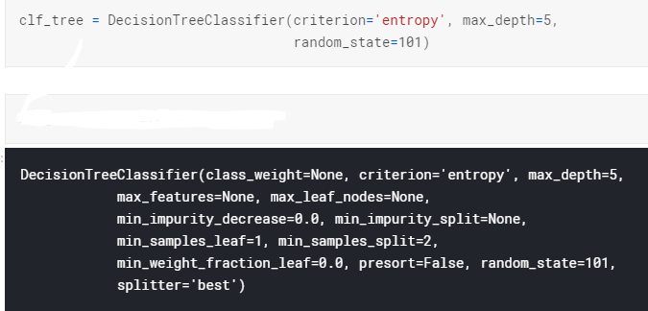

Figure 3.9: Decision tree creation

Overview of decision tree.

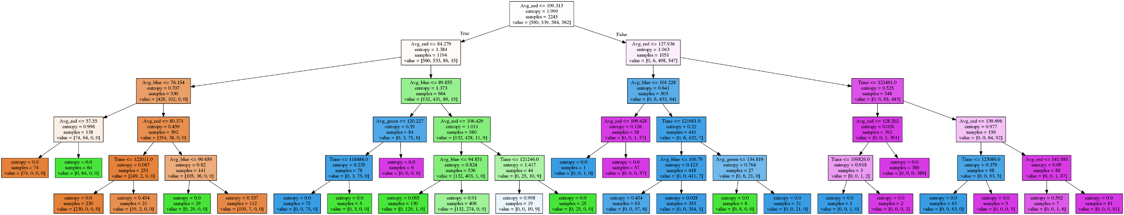

Figure 3.10: Decision tree graph

Accuracy of decision tree

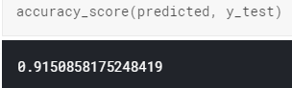

Figure 3.11: Accuracy of Decision tree

Confusions matrix of decision tree classifier

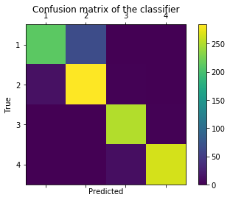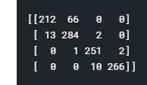

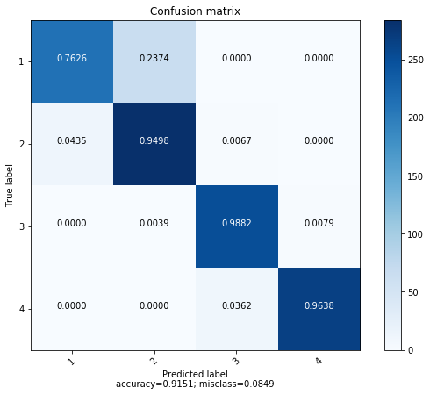

Figure 3.11.1: Confusion Matrix